
Importing the terrain into the editor.

Important note.
The mesh used though-out this experimental import is unsuitable for use with the unreal engine as it is. I am just using it to demostrate extremely high poly count problems and to save me some time doing this tutorial, I had the mesh already from page 2 of this tut :), I will be providing the vital information for contructing a suitable mesh via source image correction later.
A subtracted brush.
The image below of a brush within UnrealED is the goal for this page, I will try to guide you thru some of TerraEdit's oddities or undocumented features should I say.
So with the exported t3d file import it into the editor and manipulate its shape and form to become your main level brush, or in fact maybe one of many main level geometry brushes.
As you can imagine the combinations of what you can do with a image that becomes a brush, multiply brush combinations from joining brushes after joining images these are endless and maybe for some of you reading this tut uncharted areas of the Unreal editing experience.
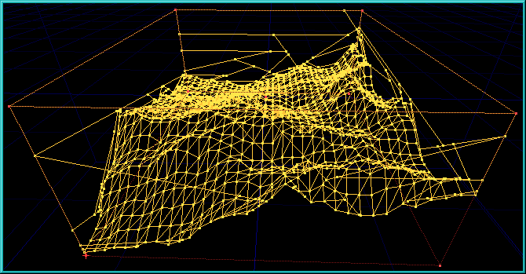

TerraEdit Importing and Exporting in detail.  Fire up the TerraEdit program and select the menu option for importing your 32x32 256 colour palette bitmap, after selecting the bitmap filename click the ok button, next you will be prompted with another dialog box asking for the grid scale and grid size.  The grid scale is what size each cell will be within the grid in UnrealEd units, well it seems to... I say this because it also effects for some unknown reason (to me at the moment) the scaling of the height of our mesh, but I know enough for now to get me and us though the importing and export process.  So for this example experimental run I will select a grid scale of 32 units and a grid size of 32x32. After hitting the ok button your image will load and a mesh will appear.  Navigating terraedit's view of our mesh is done by the mouse, left mouse drag forward/back zooms in/out, right mouse drag left /right yaw left/right right mouse drag forward/back pitch up/down, both left right mouse buttons drag for vertical up/down.  Experimenting with different grid scales and grid sizes, gives different scaled heights and stepping methods when converting the bitmaps palette information and the actual size of the bitmap, for a fuller explanation of how this works I will try to find out, but due the lack of doco experimentation has been my only means of working out the internal logic of the terraedit program.  Anyway... back to the example run, again for this experiment we just want to export the mesh so find the export menu option and save the mesh as a t3d file ready for importation into UnrealEd.  Fire up UnrealEd, set your environment if any, I always turn off vertex snapping and maybe the 3D window turn on viewing just texture mode as we will not be adding any dynamic lighting for a while.  Import that brush and see what it looks like... hummm rather small, this is because of the unit size setting within terraedit, but if set higher ie 128 per cell which I wanted for this demo, it would have effected the scale height of our mesh, anyway I know this method works for me so..  Select the t3d file we saved set the "import a brush" dialog parameters as the image specifies, solid mesh & keep original polygons intact, to be honest I have never tried the merge coplanar polygons option yet because this way works for me, plus I know a way of removing all the unnecessary polygons myself, I like to be in full control of this part of the process, but you can be as sure as eggs are eggs that Mr. HighPoly the God of all thing Terraforming will let me and all of us know if I have made an error of judgement :).  You will notice two other things straight away, humm that took a while to import, yep handling that amount of polys just takes a few seconds, also the active red brush when you navigate around seems to appear and disappear, hummm yep don't worry at all this is just a feature, it is there and again hey that brush is very small just how useful is that going to be...  Fear not, for the moment just add the brush to the world as is, go to the now added blue brushes properties and tweak the main scale values for the x, y, z values all to be 4. We can get it back to scale 1,1,1 or to what ever unrealed unit size we want for each cell.  I find that if you set the grid size to 128 just for a while this helps us aline the brushes with ease.  I expect you are thinking hummm, that doesn't look right, no matter which view you look at the blue brush it just doesn't look like the mesh we were looking at in terraedit. Ok spin the blue brush around by 180 degrees and transform it mirror about the y axis, the mesh will look right when we rebuild the level, not at the moment though.  Do a reset all for the active brush just in case, and create a standard cube or size 2048h, 4096w, 4096b, this may appear odd but we didn't really know what size our mesh would be, well the first time you ever do it you wouldn't :) I didn't when I imported one for the first time.  Subtract the cube from the world, reposition the blue mesh so it sits neatly inside and right in the botton of the cube brush, tweak the order of the blue mesh, highlight it for the brush menu set the order to last and rebuild the level.  Find a suitable texture for the subtracted cube brush, highlight one poly of the cube then press Shift_B which will highlight all polys of that brush, apply texture. You should now be looking at this image below. | 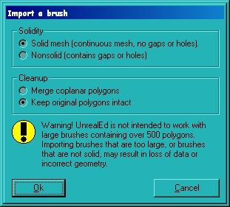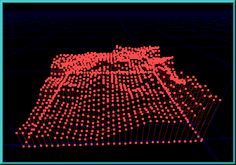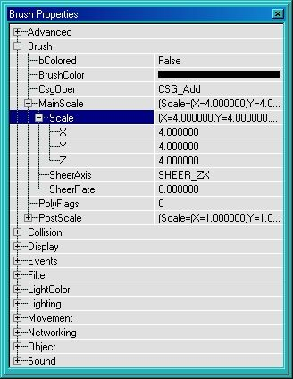

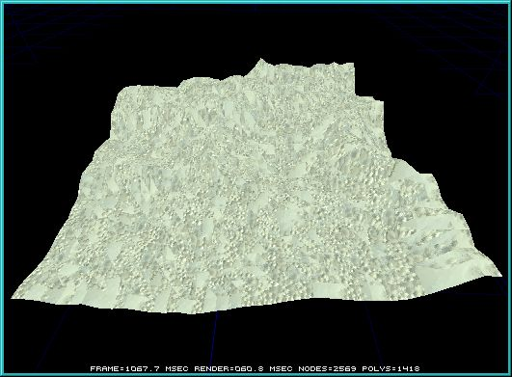

Brush inversion.  We now have a big subtracted cube with our mesh brush as an add, we also have the mesh brush scaled, not nice.  We should still at this point have a active (red) brush at the correct size and scale we want, but just to make sure do the reset the active brush using the menu brush menu. This will reset scaling, rotation and place the brushes pivot point at the it at the origin (0,0,0).  Now if not in the correct place already position the active brush so it completly surrounds our cube subtraction brush (yellow), do a rebuild for good measure just in case of any fine adjustments have been made to any of the other two brushes. Then de-intersect the active brush with the brushes it is surrounding, volia, the active brush will now be in shape to become our main level subtraction brush.  Move the active brush out of the way for a moment so you can get at the other two with ease and delete them.  Rebuild the level to remove them completely from the 3d view, reset the active brush again, you will see that it is an inversion or in fact a de-intersection so to speak of what we had before, the brush also is of scale (1,1,1) excellent.  Press the subtract active brush from world button and rebuild and save your level, incremental I find the best method this gives you a chance to go back and reload a good version if things go wrong, hard disk space permitting of course :).  Zoom on in to the terrain, if you like at this point find a suitable texture from the texture palette, load up GenEarth and select the Dirt2 texture, click on one of the mesh polys, at this point it should be all of one texture (the default new brush texture) do a Shift_T to select all of that texture then click Dirt2 from the texture palette.  Ok maybe rebuild and save again, then wander around the mesh seeing what on earth we have created.  If you are using the source image for terraedit or the source 3td file supplied for the demo you should be looking at an image like the one below.  Next... with a more suitable mesh I will employ some techniques to remove all unnecessary polys to reduce that all important poly count when viewed whilst playing a outdoor/indoor level. | 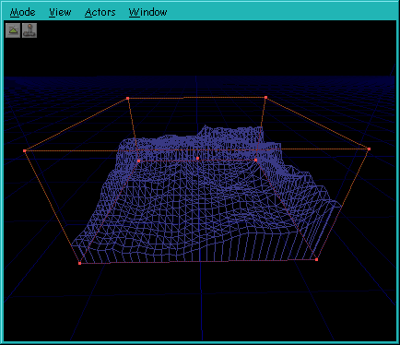

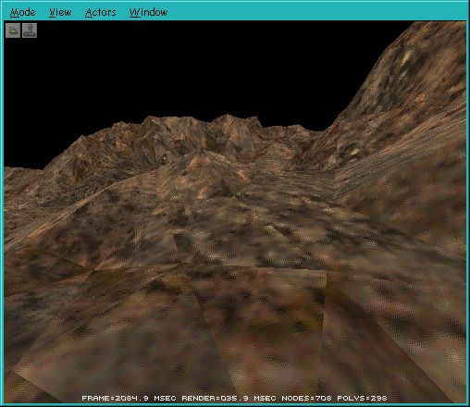
High poly counts.
The mesh used for this Terraedit export and UnrealEd import I guess could be used, but the level designer would have to invest a lot of time dreaming up methods of polygon obstruction by placing other brushes around the level in certain places to block the players view of those areas which yield a high poly count.
This mesh was generated as you know by the source image creation method with no fine image tuning at all, so basicaly just a random plasma cloud, which I believe not only it is a good method for acquireing a image with a suitable palette, but also it would give an interesting starting point for a mesh.
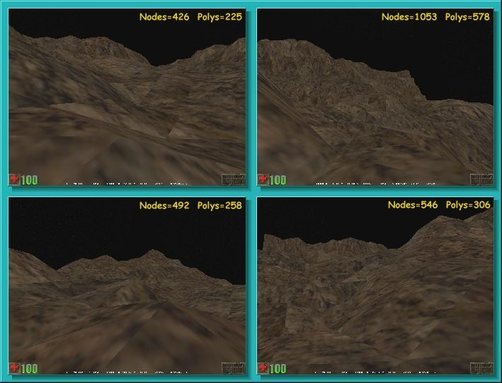


Back

